Specifications for diaries

Item | Specification | Bidder’s Offer [The bidder should clearly state his/her offer]
EXECUTIVE SMALL FILOFAX | - Product Size: 27.5cm (l) x 18.3cm (w) x 2.8cm (d)
 | - Padded executive diaries
 | - Centre clip with or without metal
 | - Capacity: A5
 | - Branding Options: Name encryption, Full Colour inserts
 | - Must have ZETDC Northern Region logo
 | - Must be stitched

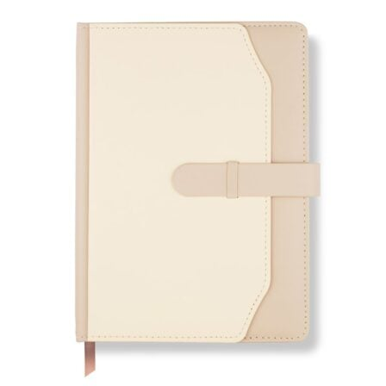EXECUTIVE DIARY

