Specification for 5 POCKET CHINO
- Relaxed 5-pocket jeans style
- Double-stitched pockets
- Flat front, no turn-ups
- Rivets and a YKK metal zipper
- 245g 65/35 Brushed Poly Cotton twill fabric

OUTBACK SHIRT

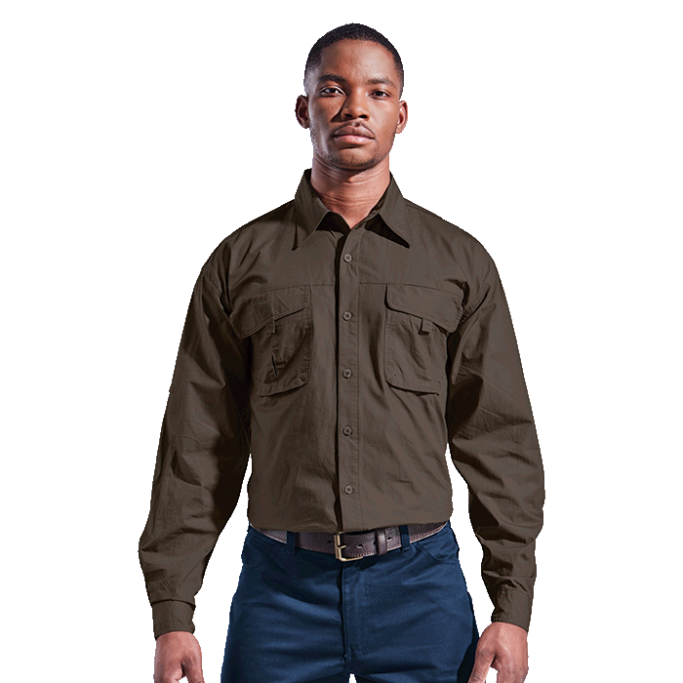
SPECIFICATIONS
- Versatile roll-up sleeve styling
- Two patch pockets with velcro flaps
- Roll-up sleeve option
- Eyelets on the pocket
- Mesh inner shoulder yoke
- Back yoke
- Vents
- 100% Cotton fabric
- Double button cuffs
- Double top-stitched finishes
- Shoulder back vent

Breezeway Golfer
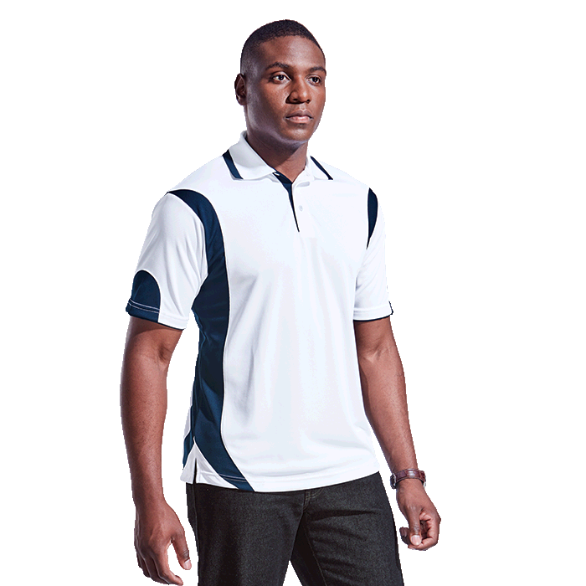

SPECIFICATIONS
- Self-fabric double cuffs and knitted collar detailing
- Contrast placket
- Two-tone sport styling
- Easy care garment
- High performance look in a high performance fabric
- Shaped inserts
- 170g 100% Polyester moisture management fabric

