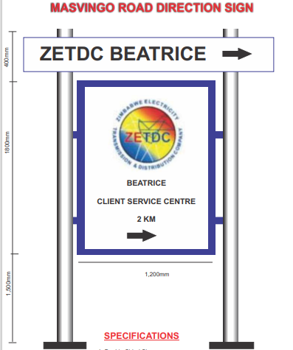

SPECIFICATIONS

N.B. BIDDERS SHOULD CLEARLY STATE COMPLY OR DO NOT COMPLY AGAINST THE GIVEN SPECIFICATIONS ON THEIR COMPANY LETTER HEAD AND FAILURE TO MEET THE SPECIFICATIONS BELOW WILL RESULT IN AUTOMATIC DISQUALIFICATION OF THE BID
SPECIFICATION | COMPLY | DO NOT COMPLY
Outdoor ink with a 5 year warrantee
Mutoh or Mimaki-Roland Machine prints only
Site visits will be made prior to order issuance for quality management control and capacity assessment in order to protect our brand reputation
Cold laminated vinyl is a must and will be demonstrated during production
Demonstrate capacity to generate a compliant ‘’Fiscal Tax Invoice
Doubled sided sign with cold laminated vinyl posted on 0.6mm galvanised sheet
Galvanised sheet to be placed on frame made of 30x30 square tube
The poles are 60mm round tube
Artwork origination is part of the package and should not be separated from the cost in the quote
Transport cost should be included in the total bid price

