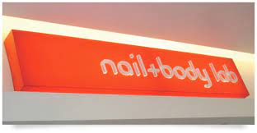

Specifications
N.B. BIDDERS SHOULD CLEARLY STATE COMPLY OR DO NOT COMPLY AGAINST THE GIVEN SPECIFICATIONS ON THEIR COMPANY LETTER HEAD AND FAILURE TO MEET THE SPECIFICATIONS BELOW WILL RESULT IN AUTOMATIC DISQUALIFICATION OF THE BID
SPECIFICATION | COMPLY | DO NOT COMPLY
Outdoor ink with a 5 year warrantee
Mutoh or Mimaki-Roland Machine prints only
Site visits will be made prior to order issuance for quality management control and capacity assessment in order to protect our brand reputation
Cold laminated vinyl is a must and will be demonstrated during production
Demonstrate capacity to generate a compliant ‘’Fiscal Tax Invoice
The light box will be mounted on buildings on some on metal stand –alone structures
Power cables from source to the light box is part of the package
Transport and installation costs are part of the package and cannot be treated separately
Artwork origination is part of the package and should not be separated from the cost in the quote

