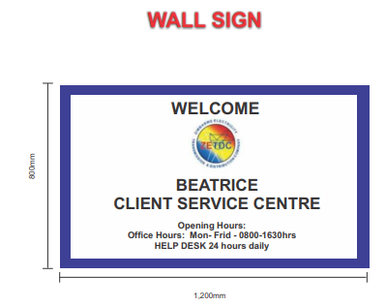
Specifications
- Outdoor ink with a 5 year warrantee
- Mutoh or Mimaki-Roland Machine prints only
- Site visits will be made prior to order issuance for quality management control and capacity assessment in order to protect our brand reputation
- Cold laminated vinyl is a must and will be demonstrated during production
- Demonstrate capability to generate a compliant “Fiscal Tax Invoice”
- Single sided sign with cold laminated vinyl pasted on 0.6mm galvanized sheet
- The sign will be mounted on the wall or standalone metal frame
- Artwork origination is part of the package and should not be separated from the cost in the quote
- Transport cost should be included in the total bid price

