ZIMBABWE ELECTRICITY TRANSMISSION & DISTRIBUTION COMPANY
A Subsidiary of ZESA Holdings

REQUEST FOR COMPETITIVE QUOTATIONS (RFQs)
Tenders are invited from registered and reputable Suppliers/Companies for the Supply and erection of Wall Signs to ZETDC Northern Region.

RFQ NUMBER | QUANTITY | DESCRIPTION OF REQUEST FOR QUOTATION (RFQ) | CLOSING DATE
59/2022 | 10 | Supply & Erection of Wall Signs  N.B* Ref attached specifications | 07/03/2022

Quotations must be enclosed in sealed envelopes and clearly endorsed on the outside with the advertised RFQ number, the description of the Request for Quotation (Purchase), the closing date and must be posted in time to be sorted into Post Office Box No. 293 Chinhoyi or delivered by hand to the Tender Box ZETDC Northern Region Stand No. 5310 G.Dube Drive Chinhoyi or can be emailed on the following email addresses: bsanani@zetdc.co.zw ,rchinoda@zetdc.co.zw or lhokoma@zetdc.co.zw on or before 10:00 hours on 07 March 2022.

Tenders should be accompanied with the following documents;
- Current tax clearance.
- ZETDC’s payment terms are strictly 30 working days after delivery hence bidders’ position must be clearly stated
- Prices should be in RTGs dollars.[ZWL]
- Bid validity of 20 days
- Delivery should be within 7 working days
- Proof of Registration with Procurement Regulatory Authority of Zimbabwe

Late bids will not be considered.

ZETDC does not bind itself to accept the lowest or any tender and reserves the right to accept the whole or part of any tender.

For further details please contact The Procurement Management Unit on telephone numbers 067-2123784/2125735-9 /2123071-3 /0772 425825/0773 452 481/0776 909 760
Emails; bsanani@zedc.co.zw, rchinoda@zedc.co.zw or lhokoma@zetdc.co.zw

Visit our website@www.zetdc.co.zw

GENERAL MANAGER (NORTHERN)

SPECIFICATIONS
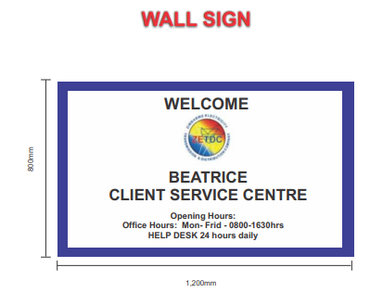

N.B. BIDDERS SHOULD CLEARLY STATE COMPLY OR DO NOT COMPLY AGAINST THE GIVEN SPECIFICATIONS ON THEIR COMPANY LETTER HEAD FAILURE TO MEET THE GIVEN SPECIFICATION BELOW WILL LEAD TO AUTOMATIC DIQUALIFICATION OF THE BID
SPECIFICATION | COMPLY | DO NOT COMPLY
Outdoor ink with a 5 year warrantee
Mutoh or Mimaki-Roland Machine prints only
Site visits will be made prior to order issuance for quality management control and capacity assessment in order to protect our brand reputation
Cold laminated vinyl is a must and will be demonstrated during production
Demonstrate capacity to generate a compliant ‘’Fiscal Tax Invoice
Single sided sign with cold limited vinyl pasted on 0.6mm galvanised sheet
The sign will be mounted on the wall or standalone metal frame
Artwork origination is part of the package and should not be separated from the cost in the quote

